C Programming

- Translator Program:
- Compiler
- Interpreter
- Assembler
- Token: Tokens in C are the smallest individual units or components of a C program.These units include identifiers, keywords, constants, operators, and punctuation symbols.The C compiler reads the source code and breaks it down into these tokens, which it uses to understand the program's structure and functionality.
Keyword: int, float while
Identifier: sum, main
Constants: 100, 55.5
Strings: “AB”, “Hello”
Operators: +, -, /, ++
Special Symbols: (), {}

- Input-Output: printf, scanf
- Operator: An operator in C can be defined as the symbol that helps us to perform some specific mathematical, relational, bitwise, conditional, or logical computations on values and variables. The values and variables used with operators are called operands. So we can say that the operators are the symbols that perform operations on operands.
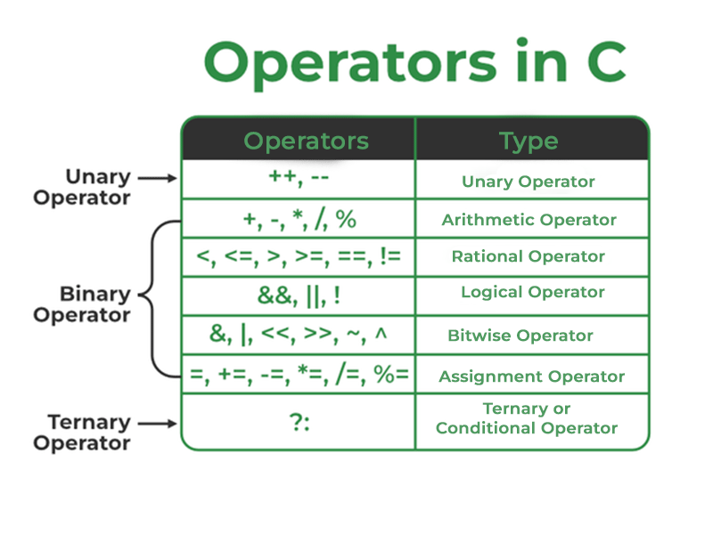
- Control Statement:
- Conditional(If, switch)
- Loop(for, while, do…while)
- Array:

